Reference Main Model Architectures for SER
Google Docs-compatible version generated from the previous CSV. The diagrams below are clean redrawn schematics based on paper descriptions, with links to the original papers and notes on where the original architecture figures appear.
Reference | Model idea | Dataset setup | Reported accuracy | Original figure available
Ahmed et al. - Ensemble 1D-CNN-LSTM-GRU | Model-A uses repeated local feature acquiring blocks with dilated 1D CNN, max pooling and batch normalization followed by FCN/softmax. Model-B adds LSTM after CNN blocks. Model-C adds GRU after CNN blocks. Model-D performs weighted average ensemble over model-... | They report results mainly per dataset, not one strict speaker-aware four-dataset protocol like our combined_strict. | TESS 99.46%; EMO-DB 95.42%; RAVDESS 95.62%; SAVEE 93.22%; CREMA-D 90.47%. | Paper PDF: Fig. 1 generic SER workflow; Fig. 2 model-A 1D CNNs-FCNs; Fig. 3 model-B 1D CNNs-LSTM-FCNs; Fig. 5 model-C 1D CNNs-GRU-FCNs; Fig. 6 weighted ensemble model-D.
Lee & Nadeem - Spectral Learning and Attention 1D-CNN | 1D-CNN processes MFCC features, enhanced by channel attention and spatial attention so the network can emphasize emotionally informative feature channels and time regions. | Reports benchmark performance on each dataset separately; not presented as our four-dataset combined strict split. | SAVEE 97.49%; RAVDESS 99.23%; CREMA-D 89.31%; TESS 99.82%; EMO-DB 99.53%; EMOVO 96.39%. | Paper PDF: Fig. 4 framework with MFCC feature extraction, data augmentation and 1D-CNN with channel/spatial attention. GitHub repository also has a figure folder and README images.
Chowdhury et al. - DCRF-BiLSTM Feature Engineering | Deep Conditional Random Fields plus BiLSTM. BiLSTM learns temporal dependencies in both forward/backward directions, while DeepCRF adds structured prediction over sequence representations. | Reports individual datasets and combined sets, including R+T+S and R+T+S+E+C. | RAVDESS 97.83%; SAVEE 97.02%; CREMA-D 95.10%; TESS 100%; EMO-DB 100%; R+T+S 98.82%; R+T+S+E+C 93.76%. | Paper PDF: Figure 1 system overview of DCRF-BiLSTM framework; Figures 2-4 show spectrogram/waveform preprocessing and augmentation visualizations.

Ahmed et al. - Ensemble 1D-CNN-LSTM-GRU
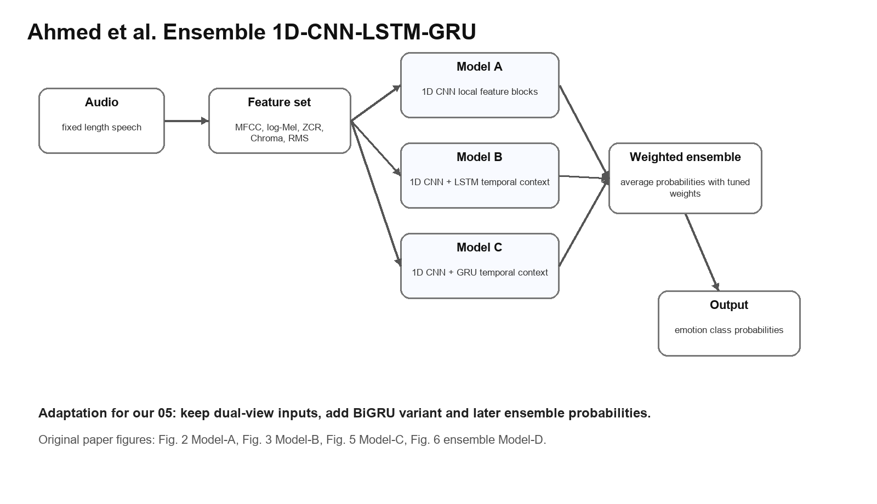
Redrawn architecture schematic for Ahmed et al. - Ensemble 1D-CNN-LSTM-GRU.
Item | Details
Paper | https://arxiv.org/abs/2112.05666
PDF | https://arxiv.org/pdf/2112.05666
Code | Not found from the paper page/search; paper does not expose an official GitHub link.
Original architecture image | Paper PDF: Fig. 1 generic SER workflow; Fig. 2 model-A 1D CNNs-FCNs; Fig. 3 model-B 1D CNNs-LSTM-FCNs; Fig. 5 model-C 1D CNNs-GRU-FCNs; Fig. 6 weighted ensemble model-D.
Datasets | TESS, EMO-DB, RAVDESS, SAVEE, CREMA-D
Dataset combination | They report results mainly per dataset, not one strict speaker-aware four-dataset protocol like our combined_strict.
Train/validation/test split | Paper states data is divided into train/test with 80:20 proportion; 20% of training data is used for validation and remaining 80% for training. This is random-style and not described as speaker-disjoint.
Preprocessing | Audio files resized to fixed length; augmentation is used to increase training data and address imbalance.
Features | MFCC, log Mel-scaled spectrogram, zero-crossing rate, chromagram, RMS energy.
Augmentation | Additive white Gaussian noise, pitch shifting, and time/signal stretching.
Architecture | Model-A uses repeated local feature acquiring blocks with dilated 1D CNN, max pooling and batch normalization followed by FCN/softmax. Model-B adds LSTM after CNN blocks. Model-C adds GRU after CNN blocks. Model-D performs weighted average ensemble over model-A/B/C probability outputs.
Reported accuracy | TESS 99.46%; EMO-DB 95.42%; RAVDESS 95.62%; SAVEE 93.22%; CREMA-D 90.47%.
Why high performance | Single-dataset/random-style evaluation, strong augmentation, multiple features, recurrent context modeling, and weighted ensemble reduce variance.
Limit for our comparison | Not directly comparable to our combined_strict speaker-aware test because their protocol is not described as speaker-disjoint and reports per-dataset results.
What to adapt for our 05 | Add dual_bigru variant, keep attention/pooling, and later add probability ensemble over dual_attention, dual_bigru and logmel_2d.

Lee & Nadeem - Spectral Learning and Attention 1D-CNN
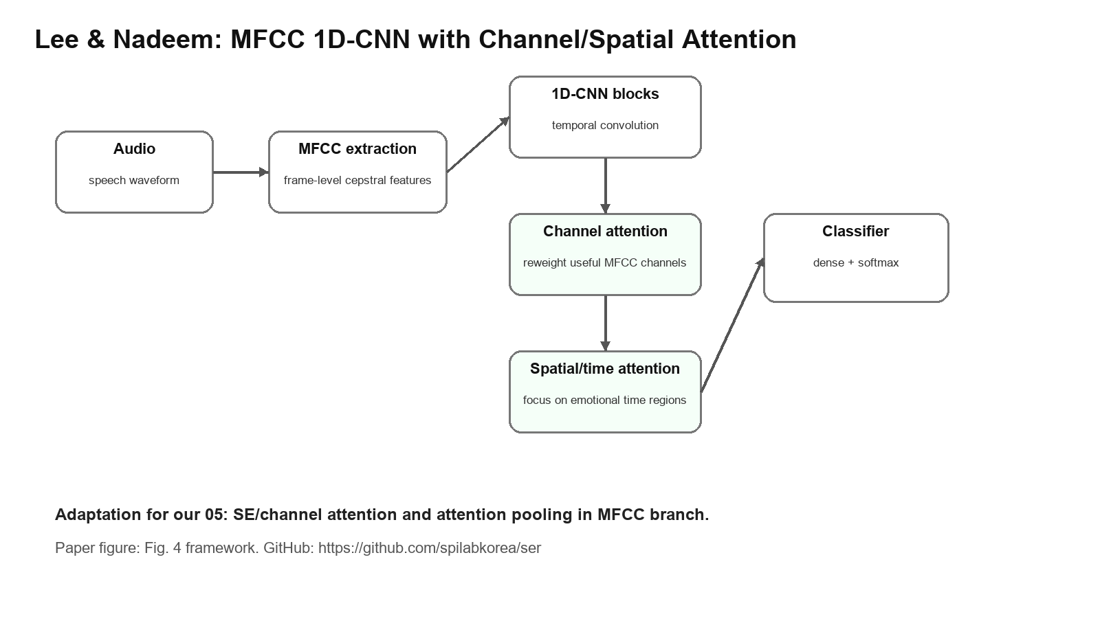
Redrawn architecture schematic for Lee & Nadeem - Spectral Learning and Attention 1D-CNN.
Item | Details
Paper | https://arxiv.org/abs/2507.03251
PDF | https://arxiv.org/pdf/2507.03251
Code | https://github.com/spilabkorea/ser
Original architecture image | Paper PDF: Fig. 4 framework with MFCC feature extraction, data augmentation and 1D-CNN with channel/spatial attention. GitHub repository also has a figure folder and README images.
Datasets | SAVEE, RAVDESS, CREMA-D, TESS, EMO-DB, EMOVO
Dataset combination | Reports benchmark performance on each dataset separately; not presented as our four-dataset combined strict split.
Train/validation/test split | Paper/repo emphasize per-dataset benchmark evaluation; exact speaker-aware split is not clearly stated in abstract/README, so treat as paper-style rather than strict speaker-disjoint unless code proves otherwise.
Preprocessing | MFCC extraction after standard audio preparation; repository lists dataset handling scripts/notebooks.
Features | MFCC features are the core representation.
Augmentation | Gaussian noise and pitch shifting; paper notes noise proportional to max amplitude and pitch shift using librosa.
Architecture | 1D-CNN processes MFCC features, enhanced by channel attention and spatial attention so the network can emphasize emotionally informative feature channels and time regions.
Reported accuracy | SAVEE 97.49%; RAVDESS 99.23%; CREMA-D 89.31%; TESS 99.82%; EMO-DB 99.53%; EMOVO 96.39%.
Why high performance | Attention explicitly reweights important MFCC channels/time regions and augmentation improves robustness; per-dataset evaluation is easier than combined strict.
Limit for our comparison | Very high per-dataset accuracy should not be compared directly with our combined_strict result unless split rules match.
What to adapt for our 05 | Use channel attention/SE blocks and attention pooling in MFCC branch; compare against logmel_2d branch to see whether 2D view helps.

Chowdhury et al. - DCRF-BiLSTM Feature Engineering
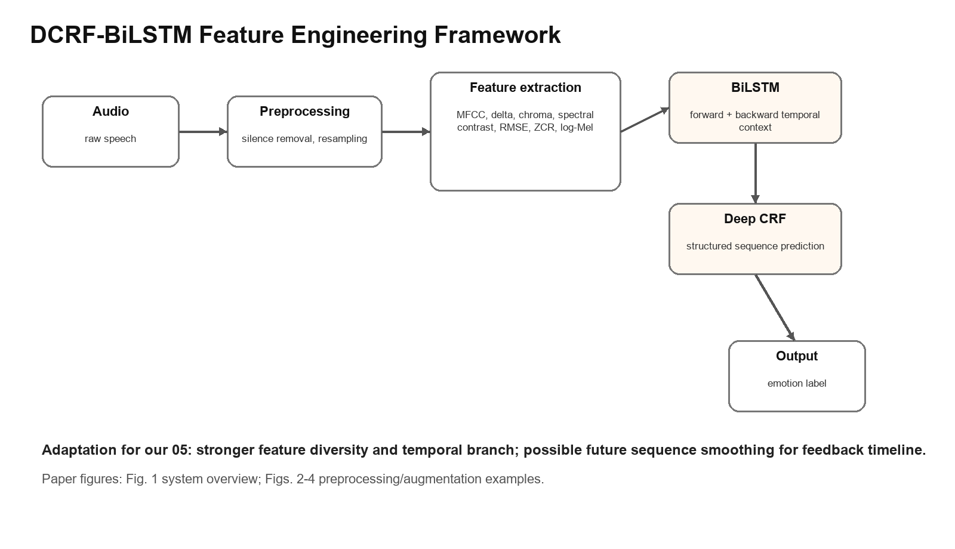
Redrawn architecture schematic for Chowdhury et al. - DCRF-BiLSTM Feature Engineering.
Item | Details
Paper | https://arxiv.org/abs/2507.07046
PDF | https://arxiv.org/pdf/2507.07046
Code | No official code link found in paper page/search.
Original architecture image | Paper PDF: Figure 1 system overview of DCRF-BiLSTM framework; Figures 2-4 show spectrogram/waveform preprocessing and augmentation visualizations.
Datasets | RAVDESS, TESS, SAVEE, EmoDB, CREMA-D
Dataset combination | Reports individual datasets and combined sets, including R+T+S and R+T+S+E+C.
Train/validation/test split | Paper describes dataset preparation and combined datasets but the exact speaker-aware train/validation/test protocol is not clearly stated in the visible methodology text; treat as non-strict until clarified.
Preprocessing | Silence removal, resampling to 22050 Hz, then augmentation.
Features | 190 selected features: MFCC, delta MFCC, delta-delta/statistical MFCC, Chroma, Spectral Contrast, RMSE, ZCR and Log-Mel spectrogram related features.
Augmentation | Gaussian noise at multiple rates, pitch shift, and time stretch.
Architecture | Deep Conditional Random Fields plus BiLSTM. BiLSTM learns temporal dependencies in both forward/backward directions, while DeepCRF adds structured prediction over sequence representations.
Reported accuracy | RAVDESS 97.83%; SAVEE 97.02%; CREMA-D 95.10%; TESS 100%; EMO-DB 100%; R+T+S 98.82%; R+T+S+E+C 93.76%.
Why high performance | Large feature set, preprocessing/silence removal, augmentation, temporal BiLSTM and structured prediction; combined data includes more varied training examples.
Limit for our comparison | Uses seven labels and five datasets; split protocol is not clearly speaker-aware, so compare as literature target, not strict baseline.
What to adapt for our 05 | Use more feature diversity and temporal modeling; future branch could add BiGRU/BiLSTM over fused embeddings or sequence-level CRF-like smoothing for emotion timeline.

How to use this document in the report
Use Ahmed et al. as the main justification for CNN-GRU/LSTM and ensemble; use Lee & Nadeem as the justification for attention in the MFCC branch; use DCRF-BiLSTM as justification for richer feature engineering and temporal modeling. When comparing accuracy, always mention that many reference results are single-dataset or not clearly speaker-aware, while our combined strict protocol is harder.

